**OUT OF THIN AIR**

**Game Design Document**

Family Crisisby Family Guys

**NOTE:**

* Please use this template for Game Design Submission. Insert your team name in the yellow highlighted text above.
* Before filling and submitting this document, please take a quick look again at the event guide attached in the link below: <https://drive.google.com/drive/folders/18GTSz3Ta6M-Z_kW1hDWJvXn4vXjnSlGb>

Short description of idea

The player starts of by randomly selecting characteristics and is then presented with random challenges that adds or removes his family coins and wealth. At the end the player with most family coins wins.

What are the big unanswered questions that you anticipate?

* What is our progression system going to be like?
* How to incorporate humor into the core of game?
* How to not make the challenges too boring?
* Should this be a card game or grid game?

Target Market & why they will have more fun playing this game

**Adults/Kids**

Parents and kids who find the challenges and relatable.

People who think the characteristics(less kids) go against their values but then they see the benefit of family planning after winning.

Soon to be parents that can have fun seeing how unpredictable their and their child’s lives will be.

Is there any challenge in creating a demonstration for this idea?

* How to make the challenges generic.
* How to add interactivity between players.
* How to add or remove family coins in a non-complex way.
* Gameplay mechanic for challenges picking (Cards or Chits?).

What do you dislike about this idea?

* Progression system might be too complex.
* It might not have humor.

Core Mechanic

* Board/Grid system for Movement.
* Family Coins.
* Wealth.
* Spinning Wheel.
* Dice Roll.

What do you like about this idea?

* Randomness
* Beginner Friendly
* Strongly related to the theme.

**Ideation bashing activity** (you can do it for all ideas you have)

**1. Which mechanic/s did you select and why?**

**Note:** You can only select mechanics from the list provided in the event guide. If you are using more than one mechanic, simply check 2 mechanics.

To know more about examples of how these mechanics are used in games, please go **pages 7 & 8** of the event guide linked above)

* Spin
* Dice
* Cards
* Boards
* Tiles
* Strings

1. Dice to move the player a certain step(s) on the grid.
2. Board that will contain the grid cells that can either be crisis, booster or sabotage.
   1. Starting Cell: The starting location of all players.
   2. Booster Cell (2): Gives a random benefit of family coins or money to the player.
   3. Event Cell: Gives a random scenario or crisis to the player that can benefit or harm them.
   4. Sabotage Cell: The cell where players have to reach to exit the grid.
3. Stars representing player position on grid.
4. Chits representing events and booster details that effecting gameplay by benefiting or harming the player
5. Spinning wheel for randomly selecting number of children and starting money.

**2- Describe the game you are designing?**

* A paragraph to explain the entire game idea

**Note:** Please do look at page 9 of the guide titled “Ideation Framework” to understand game ideation in a better manner

Our game is called Family Crisis. It involves the players (min 2) going on a journey full of unexpected events that can benefit or harm their family. It starts off by assigning the player random starting number of children and wealth by card picking then proceeding to release them on the grid world which they all have to leave. A person with more wealth and less children might be able to tackle the random scenario better and gain family coins than a person with less wealth and more children. Through different family related scenarios the game allows people to relate to it and challenge their values. We believe that if a person believes in more children no matter the cost plays the game and has his or her perspective change after seeing the benefits of family planning that gave them an edge in the game then our vision is completed.

What are the possible winning conditions in the game?

Who has the most family coins when everyone has left the grid wins.

Does the player progress resets at any point in time?

The game also has a halfway cross check that only allows players to pass towards the rest of the grid if only and only if at least one crisis occurs on their journey.

Do players collaborate with each other as well instead of just opposing each other? Describe how will it happen.

The players cannot collaborate with each other.

What type of engagement exists in your game?

Competitive Multiplayer

At least 2 players are required.

How is the game stopping you from getting to the winning condition?

The game has crisis that occur at specific grid locations. These crises harm the player based on their current number of children and wealth. If the player loses all their wealth before reaching the finish line, they lose the game. A player that has exited the grid world can go back to the starting position and step on other players causing them 5 family coins.

How do other players stop you from progressing?

Once the players have exited the grid they can step on other players and cost them 5 family coins.

How does the player reach winning conditions (define each path)

The player has the reach the end of the grid and remain the player with the most Family coins until everyone has left.

**Player Journey**

What are the possible losing conditions in the game?

Who has the least family coins.

If the player wealth becomes negative they become disqualified.

Nature of your game: Skill based, Chance, a mix of both

This game relies heavily on chance since the characteristics of our players are assigned through random card selection and the player moves through the grid world through dice rolls.

What player base your game will be most suited for.

Our research shows that this game would be better suited for both adults and kids because this game discusses reality and unpredictability of life that a lot of us tend to forget. An event that occurs in our life can be good or bad. If it is bad then if we have planned resources we can tackle it more effectively.

Any other major finding

Making a game is fun.

Are you looking to incorporating a theme or a narrative in your game? If yes, then explain.

The narrative of our game is to keep one’s family happy.

What major patterns, objects, toys, outcomes your research revealed?

The loop in the game is interesting after a player finishes securing wealth and family coins. Our research have come across the fact that the game revolves around every player going through some events while losing/earning money and family coins.

Do players opt for different roles in your game. What roles are these

All our players are parents with different number of kids.

Once the players complete the grid they become predators trying to sabotage other players.

What do people associate in general with the concept you have picked?

People usually think about how many kids they have and to manage them accordingly considering their finance as well as how to maintain better relationships.

**Research Outcomes**

**3- In your opinion, who will play your game? Why do you think that target audience people would want to play this game i.e. What makes the game fun/entertaining/satisfying for them?**

The people who are about to get married, already married couples and also teens can play this game to gain awareness regarding family planning and make decisions accordingly. Mostly younger generation would want to play this game as it would be fun as well as informative about family planning. The game is fun when a player sabotages other players while learning about the outcomes of the events and can implement them in their real lives.

**4- Add any references (videos, screenshots, pictures, doodles etc.) that can help us understand your game in a better manner.**

**Note:** It is always good to get inspired by other games. However, blatant copy will not be allowed. Furthermore, the quality / accuracy of the image doesn’t matter. It can be a badly drawn doodle but should explain the core game. The focus should be how well you can communicate.

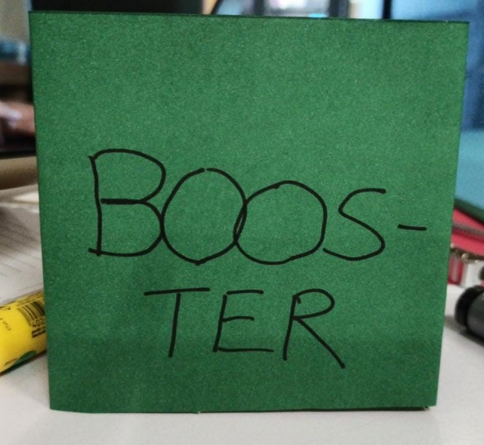 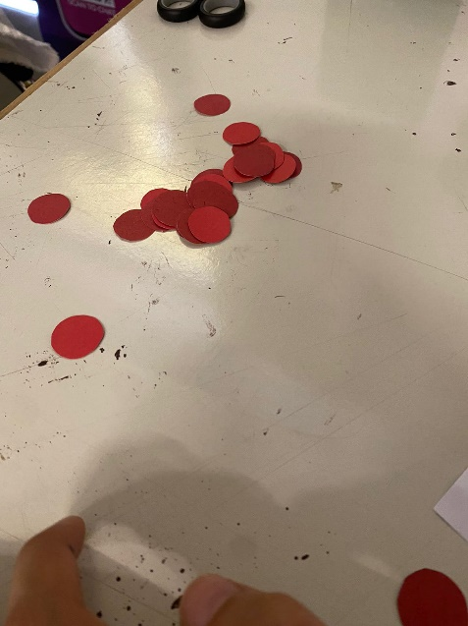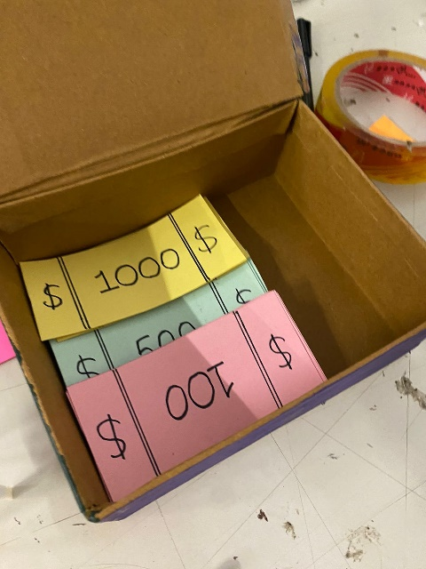 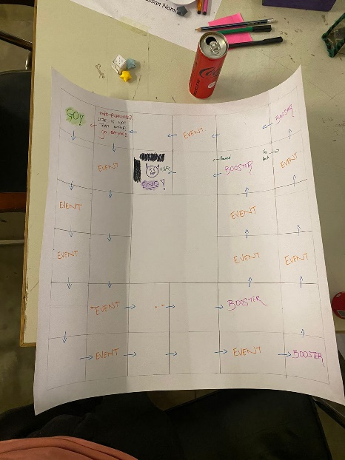

**5- Does your design have any Game Economy? What are the sources (where / how do people acquire these resources) and sinks (where / how do people spend these resources)?**

1. Family Coins (FC) represents family health to keep track of who is winning the game. Acquired or lost through crisis based on wealth you have right now. Will be recorded by coins given to player.
2. Money ($) to tackle the crisis or scenerios that will occur and gain or lose family coins when an event occurs. The amount of Money you gain or lose from crisis will be based on the number of children you have. Will be recorded by money prop given to player.

Key Differences?

* Our game has two gameplay currencies the competitor does not.
* Our events are more random.
* Our winning goal is not to exit the grid first but have the most coins.
* We can go back once we exit and sabotage other players.

What are the Key Similarities?

* Both use a grid system for movement.

Family Crisis

**Competition Analysis Activity**

Snakes and Ladder

Key Differences?

* Ludo has no random events, ours does.
* Our game has two gameplay currencies while ludo has none.
* Our player only has one prop representing their location while Ludo can have up to 4.
* The goal of our game is not to exit the grid first.

What are the Key Similarities?

* One player can step on another player.

Family Crisis

Ludo

Key Differences?

* Monopoly is about having the most businesses.
* Our game is about having the most happiest family.
* Our game has a family coins currency.

What are the Key Similarities?

* Both games have a square grid.
* Both games have currency system.

Your Game

Family Crisis

Competitor Game 3

Monopoly

**6- Describe the game you are designing?**

**Note:** Covering the following coins in your explanation is a must:

* A paragraph to explain the entire game idea
* Overall gameplay
* Single/multiplayer
* Player's perspective
* Player's goal/winning and losing conditions
* What does each player need to do to achieve the goal?
* You can highlight more areas as well

**Note :** Please do look at page 9 of the guide titled “Ideation Framework” to understand game ideation in a better manner

**Synopsis**

Family crisis is a competitive multiplayer game which involves the players (min 2) going on a journey full through a grid world of unexpected events that can benefit or harm their family.

**Player’s Perspective and Goal**

It starts off by assigning the player random starting number of children and wealth by card picking then proceeds to release them on the grid world of 32 cells which they all have to leave. Certain cells will have events which the player selects from a lucky jar that can either be a crisis or a random scenario. The scenario can entail having them paying their tuition fee for all of their kids reducing their wealth but adding to their family coins. A crisis can entail them having them make a bad investment decision and lose some of their wealth. Once the player has exited the grid they have to sabotage other players that are playing by stepping on them and causing them 5FP. Once all players have exited the grid ends with the winner being the one with most family coins. There are also two booster cells which can give a random boost of family coins or wealth to the player.

**Game Idea**

Overall, this game deals with the unpredictability of life and how family planning can give some people and edge. A person with more wealth and less children might be able to tackle the random crisis better and gain family coins than a person with less wealth and more children. Through different family related scenarios the game allows people to relate to it and challenge their values. We believe that if a person believes in more children no matter the cost plays the game and has his or her perspective change after seeing the benefits of family planning that gave them an edge in the game then our vision is completed.

**7- Draw the core loop of your game? You can use a simple flow / state diagram to describe the loop.**

Setup stage through spinning wheel.

While no player has reached the end cell continue the game. If a player lands on a booster or event cell select the chit from the jar.

Any major flaws? Loopholes, boring tedious stuff?

The cells on the grid might be too long. We can either fill more empty cells or shorten the grid world.

A player sabotaging other exited players was not as fun so they can now sabotage any other players.

What was most fun thing while playing the game?

The randomness of the events that caused me and my partners to lose the lead multiple times.

**Team Member 1:**

**Internal Playtest Result** (each team member fills their own section)

Any Other observation/notes

The currency system seems too off and it was hard keeping record of the family coins and money each player has so we decided to represent these with props.

Any major flaws? Loopholes, boring tedious stuff?

A player can get unlucky if he gets bankrupt in the early or mid game. So managing wealth and family coins is crucial for a player

What was most fun thing while playing the game?

The fun part while playing this game is to sabotage other players when one crosses the finish line

**Team Member 2:**

Any Other observation/notes

The game focuses on spreading awareness by going through the challenges of life as a family.

**Key Action Items**

Any major flaws? Loopholes, boring tedious stuff?

I felt that the game has a tendency to get boring if you do not encounter an event or booster for too long. Because of this, we are increasing the frequency of events and boosters.

What was most fun thing while playing the game?

The excitement of what the event or booster will be. Will I end up benefitting or suffering as a result of the event?

**Team Member 3:**

**Internal Playtest Result** (each team member fills their own section)

Any Other observation/notes

The board could use some arrows as we frequently got confused.

Any major flaws? Loopholes, boring tedious stuff?

What was most fun thing while playing the game?

**Team Member 4:**

Any Other observation/notes

**Key Action Items**

**Observation:** Did the player understand how to play, what part of rules were easy/hard to understand.

The player understood the game as he was already familiar with the idea.

**Observation:** Any noticeable unexpected behaviour from the player

None

**Player Type: (Mentor, Participant, Others) | Player Name: Faizan**

**External Play Test Activity** (Quietly Observing player behaviour + QnA Feedback)(One sheet per player)

**Observation:** Any particular part that excited the player or they got stuck at

He felt there wasn’t enough deduction to the money of the player.

He felt the number of children had not impacted the progression.

He suggested to add a zero children option as well.

**Questions:** Any major flaws? Loopholes, boring tedious stuff?

Players that left the grid with zero family points were stuck in a loop now.

**Questions:** What was most fun thing while playing the game?

The harshness of the game.

**Questions:** Any Other observation/notes?

**Key Action Items**

**Game Instruction Book:** Write instructions to play the game for the players. This is what you hand over to the player to tell them how to play this game.

**Setup:**

Before proceeding on the Grid World the player(s) have to randomly select the following characteristics from a spinning wheel.

* Family: Determines the number of children (1-4) the player has.
* Wealth: Determines the starting money ($1000, 1500, $2000, $2500) the player has.

All the players start with 10 FP (Family coins).

**Game Rules:**

* All the player(s) start on position 1 and have to exit the Grid World by reaching position 32.
* The arrows shows where you can move from each cell.
* If a player lands on a event cell they have to randomly pick an event from the event jar. Example:
* A player with 4 children picks an event that says, “School Fees Payment $500 per Child +5 FP” so the player will have lost $2000 but would have gained 5 FP.
* A player with any number children picks an crisis that says, “Your child was caught cheating -5FP” so the player will lose 5 FP.
* If a player lands on a booster cell they have to randomly pick a booster from the booster jar. Example:
* A player picks a booster that says, “You have won a Family Trip. +5FP”
* Upon reaching the cell 20 the player has to have passed at least one event cell else they go back to the first cell.
* Upon reaching the final cell the game ends and the final family coins are considered.
* Cell 30 allows you to go back and get more family coins or proceed to the final cell.

**Currency Rules:**

* If player loses all of their money they get disqualified.
* Family coins can’t go below zero.